- Created a VPC in us-east-1 region with 2 subnets ( one public subnet and one private subnet) in each availability zone.

Vpc-03b18309d6645d605

- In availability zone us-east-1a

Public subnet : subnet- 0293fb6bc4cda1ebd

private subnet- subnet-0b818987c95060263

In availability zone us-east-1b

Az1 pub Public subnet : subnet- 0b2b26264bb1fa0cc

Az1 priv private subnet- subnet-0e458e7f7a69b987d

In availability zone us-east-1c

Public subnet : subnet- 065edb85e0b995765

private subnet- subnet-0a902fc1b3fe34b45

- Three ec2 instances are launched in above three private subnets.

Priv1 : i-0f52099a9a8279e66

Priv2 : i-04d00913c777be0ca

Priv3 : i-0bc091fdf9a73b832

a bastion server (ec2 instance) is created in public subnet (public subnet-0293fb6bc4cda1ebd) in availability region us-east-1a

Bastion host : i-0bbf42eef54a03221

In order to Restrict the security groups of the private instances to allow SSH only from the bastion host.

I assigned the security group of bastion host(the public instance) to the inbound

rule in security groups of all the private instances

I can assign the IP address of bastion host but since it has public IP address it will be

changing always so instead I attached its security group to the inbound rules in

security group of all the private instances

Security group of private instance in AZ1 ( us-east-1a)

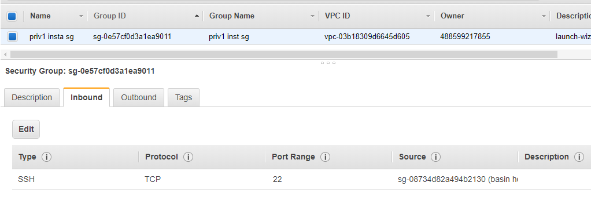
Security group of private instance in AZ2 (us-east-1b)

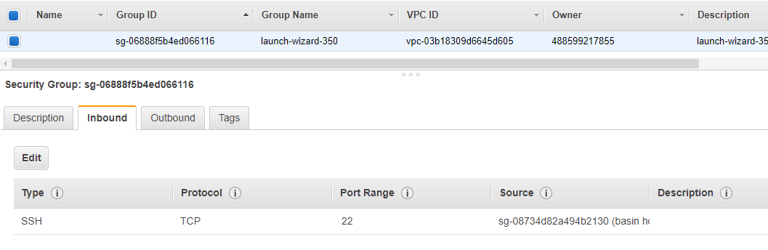

Security group of private instance in AZ3 (us-east-1c)

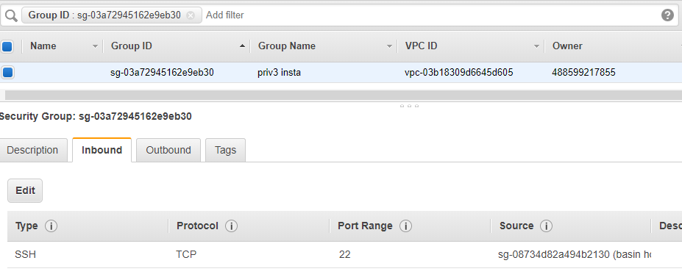

The inbound rules in the security groups of the bastion host are assigned with the

Quantiphi IP ranges so that the access to the Bastion host is restricted.to only

quantiphi IP ranges.

Security group of public instance(bastion host) in AZ1 (us-east-1a)

